Description on how to download futures Market data from INO.com Exchanges by Commodity:

This document describes the setup and process
- to get updated ticker lists (.tic files) for all the contracts grouped by futures commodity every time you do a last-trade download (daily data)
- to get last-trade data
- to get historical daily data

While this example shows the commodities in the “Metals” market/category, the design is made generic enough to download all the other futures market data using the same format file.

In addition, data for all the commodities belonging to the same futures market/category, in this case the “Metals” category, will be stored in the folder “metals”. For this, each .tic file needs to have a prefix of ‘_’, and all the .tic file names have to be listed in the _xferdir.cfg file in order to redirect all the data to the category folder.

Set-Up for Symbol Refresh and Last-Trade Data Download:

- Copy the following line and append to your existing “mywebserver.txt”, or simply substitute it the attached “mywebserver.txt”.

_INO_C_XXXX,http://quotes.ino.com/exchanges/contracts.html?r=XXXX,L3,INO_C_L3.fmt

- Place the “INO_C_L3” file to the “fmt” subfolder in the data file location.
- Run HSQuote Plus and set up the screen as soon. Please note that the portfolio name should be “_INO_C_NYMEX_HG.tic” for COPPER, because the line added in the “mywebserver.txt” is “_INO_C_XXXX” where the XXXX is generic to accept other portfolios, such as “_INO_C_NYMEX_GC.tic” for GOLD, or “_INO_C_NYLF_YG.tic” for GOLD (MINI), etc.
- Set up the ‘_xferdir.cfg’ file. The attached ‘_xferdir.cfg’ file is just an example for the metals category, and the redirected folder path will be different for each user. Each line contains one commodity .tic file and the market/category being channeled to. Examples:

_INO_C_NYMEX_HG,I:\My Projects\HSQuote Data\metals
_INO_C_NYMEX_GC,I:\My Projects\HSQuote Data\metals
_INO_C_NYLF_YG,I:\My Projects\HSQuote Data\metals
_INO_C_NYLF_ZG,I:\My Projects\HSQuote Data\metals
_INO_C_NYMEX_QO,I:\My Projects\HSQuote Data\metals
_INO_C_NYLF_MME,I:\My Projects\HSQuote Data\metals
_INO_C_NYMEX_PA,I:\My Projects\HSQuote Data\metals
_INO_C_NYMEX_PL,I:\My Projects\HSQuote Data\metals
_INO_C_NYMEX_SI,I:\My Projects\HSQuote Data\metals
_INO_C_NYLF_YI,I:\My Projects\HSQuote Data\metals

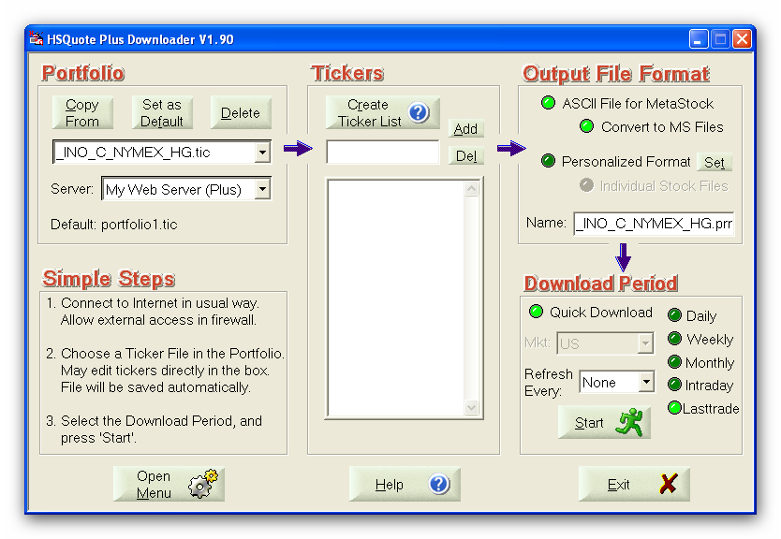

Note that in the Tickers List, we do NOT need to enter all the symbols on the web page http://quotes.ino.com/exchanges/contracts.html?r=NYMEX_HG as shown below. The trick is that in the “_INO_C_L3.fmt” file, we have added a line:
1@myRenewTickers#Renew Ticker List before download (default: 0, No)
This line tells the program to always renew the ticker list before downloading new data. Of course, you may choose to manually enter the symbols and delete this line ☺.

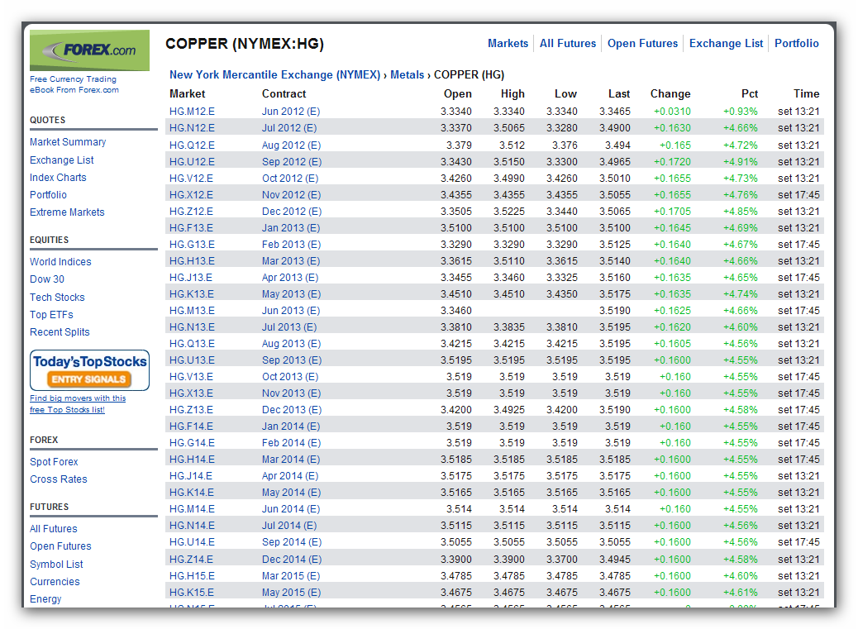

Last-Trade Daily Data Download:

This web page refreshes the last-trade data regularly. You may download in the middle of the session or at the end of the day. Please note that the data will carry the date that the download is done. So you need to do the download on the same day. You may set up the Microsoft Task Scheduler to download data on a fixed schedule.

Set-Up for Historical Data Download – Daily Data:

- Copy the following line and append to your existing “mywebserver.txt”, or simply substitute it the attached “mywebserver.txt”.

_INO_C_XXXX,http://club.ino.com/quotes/data/?q=1&ticket=marketclubref&s=SSSS&w=d&f=csv,D1,Futures_INO_DI1.fmt

- Copy the “Futures_INO_DI1.fmt” file to the “fmt” subfolder in the data file location.
- Run HSQuote Plus and call up the ‘Futures_INO_livestock.tic’ portfolio as shown.

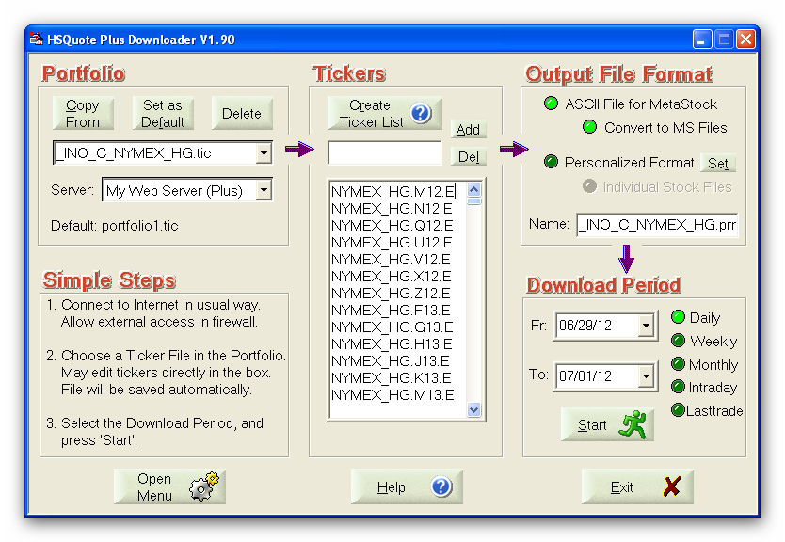

Historical Daily Data Download:

As the last-trade daily data download can automatically download symbols. You want to run historical daily data AFTER the last-trade daily data has been downloaded.

For the first time, you may set the Fr date as far back as 01/01/2001, but data may not be available for all some contracts. That is all you need to do before “Start” to collect historical data.

Also note that for ‘spread’ contracts, there may be no historical daily data.

